Chris Rodgers

Execute the Mongo Command

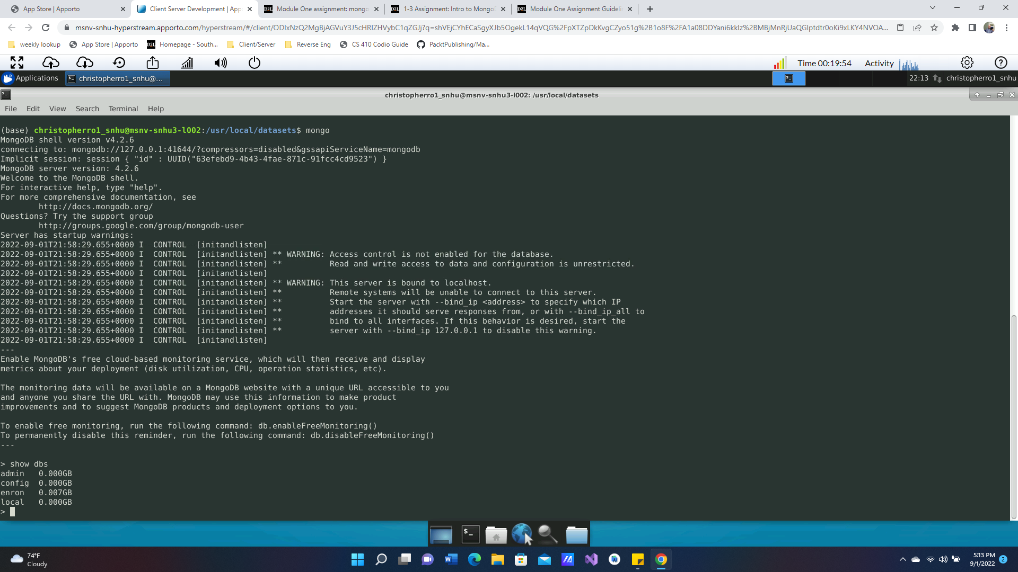

Load the data base with the Linux command line

Show the Port #

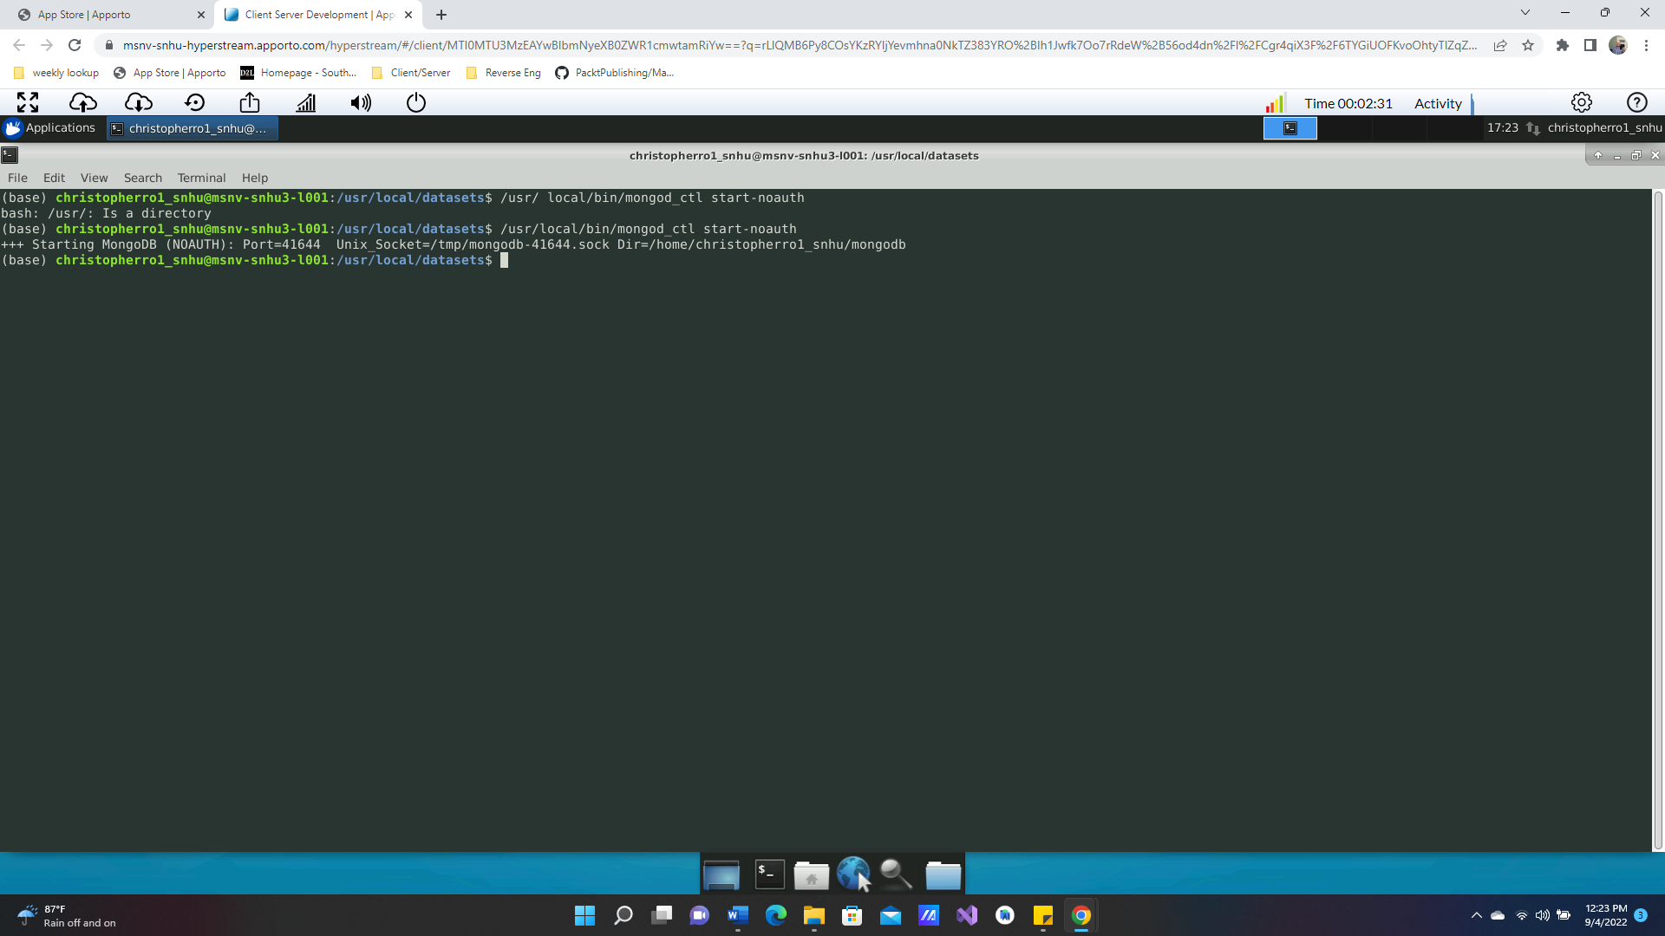

Retrieve a document following commands

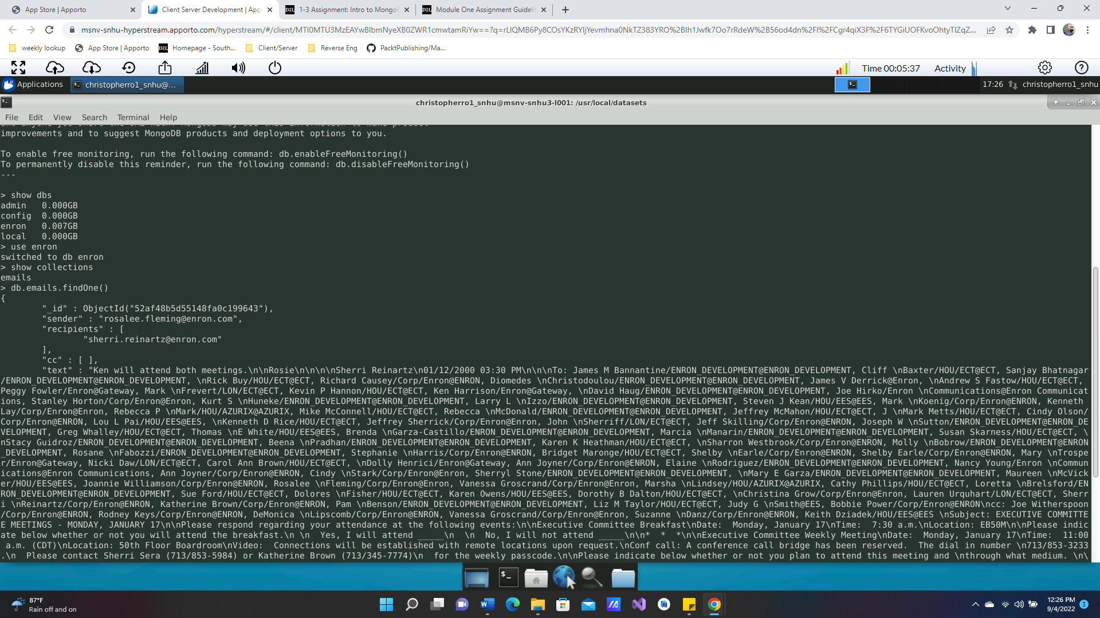

Show Size of a document

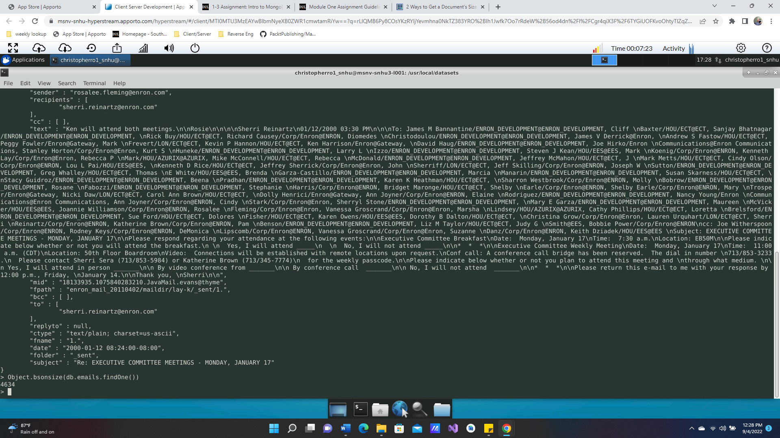

Show the size of a collection

